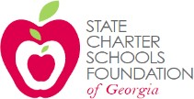

State Charter Schools Foundation

Board of Directors CALLED MEETING AGENDA

April 15, 2020, 2:00 p.m.

Via Conference Call

888-808-6929, code: 5206746#
State Charter Schools Foundation of Georgia
508 Twin Towers West, 205 Jesse Hill Jr. Drive, Atlanta, Georgia 30334

Welcome, Chris Sears
  - Call to order

SCSF COVID-19 Relief Fund, Chris Sears
  - Summary of grant applications received by schools
  - Vote to approve grant award recommendations

- Adjournment

