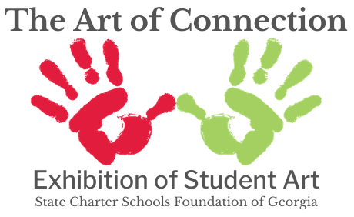
Display your creativity in the State Charter Schools Foundation of Georgia’s (SCSF) annual art exhibition! The SCSF believes that encouraging children and teenagers to create art helps them form connections with the world. Artistic engagement supports the development of cognitive and emotional skills, giving children an outlet to express themselves and explore their ideas.
Awards
Three entries will be awarded prizes in each of the four grade groups (see below, under Eligibility). Awards will be determined by the combined scores from impartial judges. Our team of judges is comprised of professional artists and/or art instructors from around the state!
1st Place - $100 Amazon gift card & display at the SCSF office
2nd Place - $50 Amazon gift card
3rd Place - $25 Amazon gift card
Eligibility
This opportunity is exclusive to Georgia’s state charter school students. All students currently enrolled in a Georgia state charter school are eligible to participate. For a list of Georgia’s state charter schools, visit scsfga.org/schools. Eligible participants will be broken into the following four grade groups.
Junior Elementary School: Pre-K through 2nd Grade
Elementary School: 3rd Grade through 5th Grade
Middle School: 6th Grade through 8th Grade
High School: 9th Grade through 12th Grade

Submission
The SCSF will accept 2-D visual art entries electronically through the submission portal from January 22 through February 16, 2024. For a link to the submission portal, visit scsfga.org/art-of-connection-2024.
- All entries (for students under 18) must be approved by a parent or guardian who consents to display the art on the SCSF website’s digital art gallery with the student’s first name, grade, and school name. Students who are 18 or older may provide their own consent.
- Entries will be submitted via file upload (either a high-quality image of the work or an original digital file). Please make sure the picture is clear and that the orientation of the file is correct (do not upload the work sideways or upside down). This file will be used for judging and will be posted to the digital art gallery.
- Teachers may submit entries on behalf of students. Parents/guardians will be notified of the submission via email and will have the opportunity to withdraw the entry from the contest.
- Winning entries will become the property of the SCSF, and they will be displayed at the SCSF or State Charter Schools Commission of Georgia office. The original entries will be mailed or dropped off to the SCSF after judging.
Rules
- Any 2-D work of art may be submitted. This includes paintings, drawings, digital photos, collages, graphic designs, or a combination of media. Use your imagination!
- All entries must be the work of one state charter school student without the assistance of any other student or adult. Entries should be reflective of the entrant’s age and ability.
- Under no circumstances may a student enter someone else’s work as their own or include someone else’s work as a part of their entry.
- Entries must be at least as large as a standard piece of letter-size paper (8 ½” x 11”) and no larger than 24” x 36”.
- Copyrighted images are not allowable unless they are included as a small part of the entry and not the focus of the entry. For example, the logo of a product may be included in a photo in the background, but it cannot be the focus of the photo. Excerpts from newspapers, magazines, or other media are acceptable if they are part of the design and not the focus of the entry.
- If an entry includes the likeness of another person, please request permission from that person or their parent/guardian before entering it in this contest.

